

**INDUSTRIAL ATTACHMENT REPORT**

**TRAINING INSTITUTION:** THE ELDORET NATIONAL POLYTECHNIC

**NAME:** SHELMITH CHELAGAT

**COURSE:** DIPLOMA IN SOCIAL WORK AND COMMUNITY DEVELOPMENT

**ADM NO:** 2023P00461

**DEPARTMENT:** LIBERAL

**ORGANIZATION ATTACHED TO:**  REALE HOSPITAL

**PERIOD OF ATTACHMENT:** 9th JANAURY TO 3rd APRIL 2024

**SUPERVISED BY:** MR**.** RICHARD TOROREI.

**ASSESSED BY :** MS.KANDA

DECLARATION

I Shelmith Chelagat declare that this report is my original work and it has never been submitted to any institution of higher learning for academic purpose. I further declare that all materials cited in the report which are not my own have been dully acknowledged.

Author :……………………………………………………….

Date: ………………………………………………………….

Signature: …………………………………………………….

ACKNOWLEDGMENT

First, I want to thank the Almighty God for bringing me this far and keeping me sound and safe with good health during the entire attachment period.

I also wish to thank ms.Kanda who took her time to asses me.

I also thank my parents whose moral and financial support has remained unrelenting, dear friends and colleagues whose motivation during the attachment kept me moving.

DEDICATION

I dedicate this work and thank God for his protection during my entire attachment period also in consideration are my supervisor, hospital staff and my parents.

ABSTRACT

The purpose of this report is to provide the details of the institution of attachment, a description of all the activities undertaken during the attachment period, the skills acquired and the challenges faced during the same. This report therefore provides a summary of the activities and duties carried out as well as experienced gained.

# LIST OF ABBREVIATIONS

SWOT –Strengths, Weaknesses, Opportunities and Threats

SGBV _Sexual and Gender Based Violence

VAWG _Violence against women and girls

GBV –Gender Based Violence

FGM –Female Genital Mutilation

**TABLE OF CONTENTS.**

Declaration…………………………………………………………………………………….2 Acknowledgment……………………………………………………………………..……….3 Dedication……………………………………………………………………………………..4 Abstract…………………………………………………………………………….………….4

Abbreviation……………………………………………………………………………..…….5

CHAPTER ONE………………………………………………………………………………7

Introduction……………………………………………………………………………………7

Background……………………………………………………………………………………8

Organization structure…………………………………………………………………………9

Vision, Mission and Values……………………………………………………………………9

Objectives of the attachment…………………………………………………………………...10

CHAPTER TWO……………………………………………………………………………….12

Work experience………………………………………………………………………………...12

Sections attached and skills acquired……………………………………………………………13

CHAPTER THREE…………………………………………………………………………...…14

Challenges………………………………………………………………………………………..14

Recommendation…………………………………………………………………………...……15

Conclusion……………………………………………………………………………………….16

**CHAPTER ONE**

1.1 Introduction

The industrial attachment report deals with my attachment with compassion, within Reale Hospital situated in the Rift Valley region Uasin Gishu county.

The discussion in this report revolves around social work, community health, guidance and counseling, health talks, disabilities and poverty eradication as social and economic issues.

The training time allowed me to link the theoretical principles learned in higher learning institutions and the real life professional and technical application.

1.3 Organizational structure(chart)

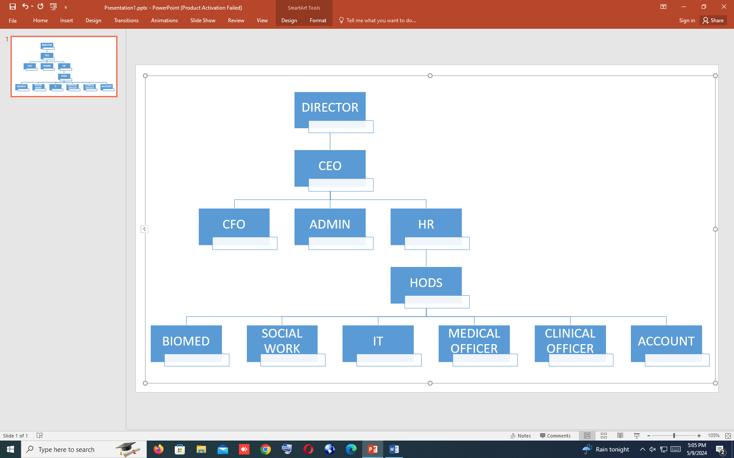

1.4 Vision

Working tirelessly to save lives and make a difference.

1.5 Mission

To offer patients the best care using advanced technology in an atmosphere of trust, safety and comfort.

1.6 Values

* **Integrity.**
* **Respect**.
* **Professionalism.**
* **Accountability and Transparency** .
* **Teamwork.**
* **Discipline.**

1.7 Objectives of the attachment.

1. To obtain a progressive position where it will be possible to expand my knowledge and scope so as to develop organization image and my career in such a way that I will exercise responsibility and creativity in the environment to overcome obstacle encountered to achieve goal and objective.
2. Acquisition of practical skills and appropriate work ethics before entering the labor market.
3. To maximize the development of human potential and fulfillment of human needs through commitment.
4. Working with and enabling people achieve the best possible levels of personal and social well-being.
5. To achieve social justice through social development and social change.
6. Counseling patients, families and the community at large psychosocial rehabilitation, home based care and placement of patients.

**CHAPTER TWO**

2.1 Work experience

During my attachment I conducted various tasks assigned to do in which I conducted interviews with individuals and families to access and review their situation, undertake and write up assessments in collaboration with professionals in various departments, offer information and support, recommend and sometimes make decisions about the best course of action, maintain accurate records for clients and participate in meetings e.g., health talks.

In addition, I also educated patients on how to navigate the health system, connecting them to resources and empowering them to use these resources .

2.2 Skills acquired.

### 2.2.1 Good communication skills

Now, I am being able to communicate well with different classes of people. Whenever I attended to guests, I gave good and understandable explanations to their satisfactory point about the department and directorate's services without any difficulties.

### 2.2.2 Patience

Some guests who visited the directorate showed open dissatisfaction to a point of insulting us especially when they never got what they wanted. I gained the skill of being patient so that I could be able to tend to their needs properly and calmly.

### 2.2.3 Product knowledge

I knew well what it was that we provided to the visitors at the directorates hence I could confidently give clear information about them and also answer questions that they had.

### 2.2.4 Confidence

I gained confidence especially whenever I interacted with guests. I attended to visitors from different countries and ages, even large groups confidently without stammering hence gaining the visitor’s trust and interest.

### 2.2.5 Adaptability

I was able to adapt easily to the different departments which I was taken to without any problems.

### 2.2.6 Professionalism

Most visitors did not know or care if I was a student doing attachment. They saw me as an employee of the organization, so when they complained, they expected me to deal with their complains in a professional manner, which I did.

### 2.2.7 Time management skills

I reported to work on time and was also able to serve the visitors within the shortest time possible.

### 2.2.8 Empathy

With this skill, I was able to listen and understand problems that the visitors were experiencing and look for a solution so that they could have a good experience.

**CHAPTER THREE.**

3.1 Challenges

1. Role classification – In other departments social workers role is not well classified what he or she is supposed to undertake.
2. Decision making process – When differences emerge across professions as to decision making process and outcomes.
3. Working with vulnerable people – Being exposed to these highly emotional situations can lead to compassion fatigue. It can be difficult to remain unaffected by distressing cases.
4. Complying with government regulations – Despite wanting to take immediate action to help clients you have to hold back and comply with the standard protocol outlined by the government hence adding another obstacle in the line of work.
5. Language barrier – It is difficult to communicate with people who only speak their cultural language .

3.2 Recommendations.

* More funds should be pumped to the social work office to facilitate training, home based care and field study.
* Practicing resilience to cope up with emotional and distressing situations.
* Encouraging collaboration with other stake holders to speed up the decision-making process.

3.3 Conclusions.

The industrial attachment provided me with an opportunity to put theory into practice, it also provided me with the ability to asses my interest in the related career and to equip myself with the expectation of working in a highly competitive environment.

In addition, the training has instilled me integrity, punctuality and interpersonal skills. I have quiet learned a lot e.g., execution of tasks assigned to, adhering to clients need and developing a good rapport with staffs and colleagues. I would say my objectives were met and well adhered to not only did I acquire various skills but also self-motivation towards my career.